Energy and Skills for Miniball

The Energy Systems

To participate in specific physical activity, the muscles require energy. This energy is obtained predominantly through three energy systems.

The immediate energy system - Short and sharp
(Anaerobic alactic – ATP-CP system)
This system provides immediate energy for short bursts (1-15 seconds) of maximal intensity exercise. This system uses energy that is stored in the muscle. It requires no oxygen (anaerobic) and produces no lactic acid. It is important for strength, speed, and power events.

The intermediate energy system – Huff and puff
(Anaerobic lactic system)
This system provides energy for moderate to high intensity exercise (10 seconds- 3 minutes). This system produces a by-product of the energy production, called lactic acid. It is important for high intensity, endurance, and power events.

The long term energy system – Let’s go all day
(Aerobic system)
This system provides energy for low to moderate intensity exercise for longer periods of time (3+ minutes). There is generally no lactic acid produced. It is important for endurance events.

Possible Lesson Sequence

Lesson One
Introduce class to the concept that fitness is specific.
In groups ākonga brainstorm:
- the skills required for a game of mini ball, for example dribbling, passing, catching, shooting, and combinations of these to enhance the game situation;
- the types of movement that occur in a miniball game, for example sprinting and short/quick movements, and relate these movements to the different energy systems; and
- the different physical fitness requirements of miniball and golf?
- (Golf was selected here to challenge a perception that playing golf doesn’t require physical fitness. Another activity that provides a stark contrast to miniball could be used.)

Debrief questions
Focus:
What are the three energy systems the body uses while exercising and how do they differ from one another?
Based on your understanding of the types of movements used in miniball and the three energy systems, what type of physical fitness exercises would be most beneficial to a miniball player?

Lesson two

Skills session including passing, catching, and dribbling.
- Basic chest pass
- fingers spread, placed behind the ball. Bring hands to chest, push hands at target, while stepping forward in direction of throw, releasing ball to ensure accurate throw.
- Receiving throw
- hands in front of chest to provide receiving target. Bring hands and ball to chest to absorb throw and to be in position for quick release/ throw to next target.
- Dribbling
- In a slow walk bounce ball at front right, if right handed and front left if left handed, not directly out in front of player but slightly to the side. Encourage consistent waist high bounce. Treat ball like a yoyo bringing hand up to waist with the ball and pushing back down to ground.

Design activities that enhance these skills for example, relays, dribble around cones and pass to fellow players, and games of similar nature.

Encourage communication between thrower and catcher through peer feedback on the performance of the skills.

ākonga can use a one to five scale to rate each performed skill by raising the appropriate number of fingers:
- one finger equals terrible skill execution for example passing with inappropriate speed and inaccurate direction
- five fingers equals brilliant skill execution, for example passing with speed and accuracy.

Another method is the thumb continuum:

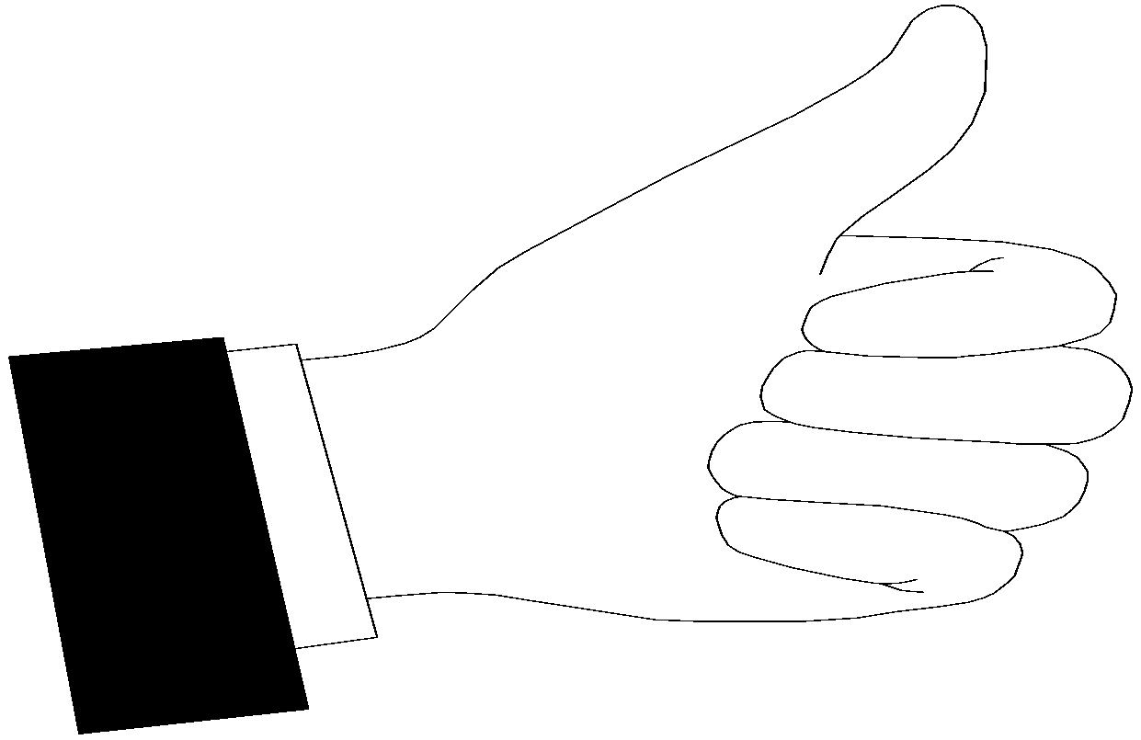 |  | 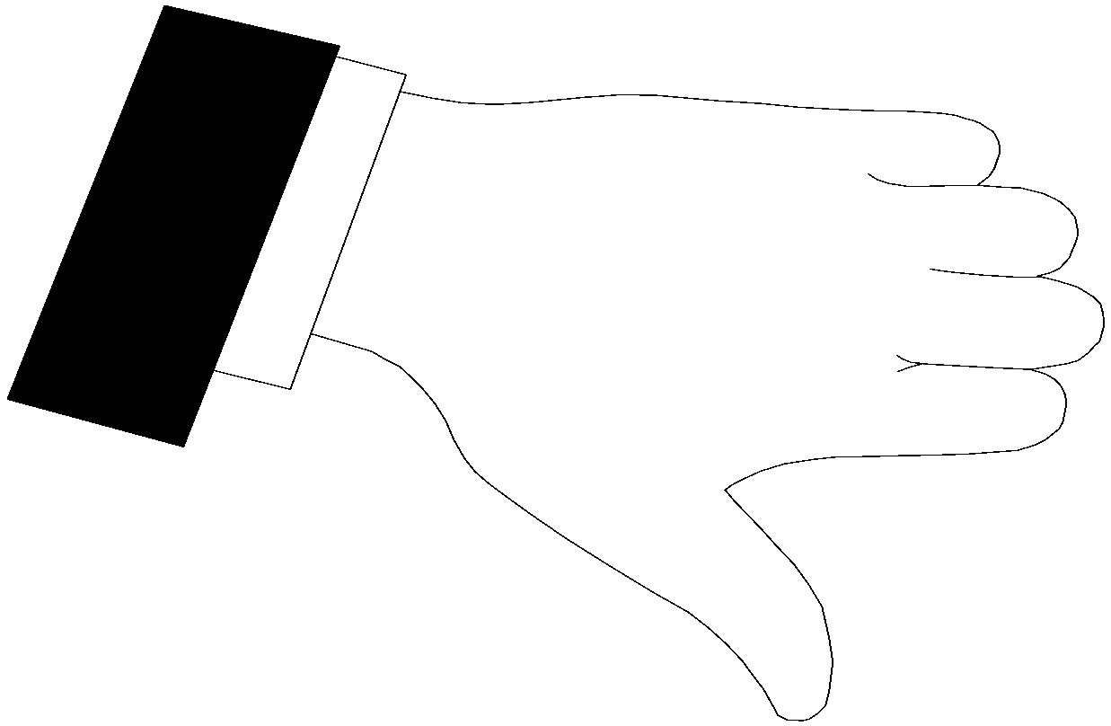
Thumbs up is brilliant skill execution | Thumb somewhere in the middle depending on perceived level of skill execution | Thumbs down is terrible skill execution

At the conclusion of this lesson ākonga enter their perceived skill level on the self assessment rating chart.

Lesson three

Warm up/stretch
Teacher runs activities which combine the skills taught in lesson two (passing catching, and dribbling).

Introduce shooting. Right-handed shooters have right hand placed behind ball and the left hand is used as a stabiliser.
Practice shooting from various distances and angles. Make the shooting into a competitive game, for example how many shots can you get into the basket from ten attempts?
Develop lay up (this aspect is useful for players who demonstrate shooting ability).

Ākonga enter their perceived shooting skill level on the self assessment rating chart.

Lesson four

From the lesson one brainstorm on energy systems, teacher directs a number of physical fitness activities that originate from the three energy systems.

- Immediate energy system (1-15 seconds) for example, rapid shuttles over 5 metres. Rob the nest game.
- Intermediate energy system (10 seconds-2 minutes) running for longer periods, for example 400 metres, and exercise circuits.
- Long term energy system (over 3 minutes), for example shuttle runs over the length of miniball court to see how many lengths can be achieved during this time, pair relays, team endurance relays, hounds and hares cross country, orienteering.

Set homework activity for each ākonga to come up with own miniball training programme. The programme must include two skills based and two physical fitness based activities. The skills must focus on areas of weakness as identified on the self assessment rating chart and the physical fitness activities must focus on the specific energy requirements for miniball (primarily intermediate energy system).

Lessons five and six

Ākonga are placed into teams and each individual demonstrates and leads their team though the activities they have designed, stating why they selected these activities.
Each ākonga receives a peer assessment rating sheet from each member of their team.

Lesson seven and eight

Teams play round robin games of miniball.
Teacher may wish to modify the rules so that all players are able to demonstrate skills they have learnt.

Debrief question
What would you do to improve your physical fitness if you were training for another physical activity for example, kapa haka, gymnastics, rugby league?

